Green Thumb Design Document

Feedback loop, starting with X coins:

* buy seeds
* plant seeds
* seeds grow into plants
* plants produce fruit
* fruit can be processed into more seeds
* OR sold in bulk for coins
* coins can buy more varieties of seeds

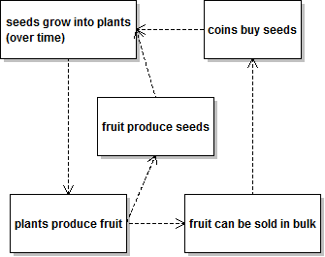

Prototype Design

For a simple prototype (C++, SDL) I’ll need to create a plant object, with its seed type, age, and any boosts it has. These can be planted anywhere on the screen, for now I don’t care.

I need to store coins, and several bags of seeds.

I also need some way of purchasing the seeds.